AfyaLink: A Web-Based Healthcare Human Resource Management System (HRMS)
SYSTEM DOCUMENTATION
SUBMITTED BY,
Joseph Ogwe Were
DCS-03-8586/2024

A SYSTEM DOCUMENTATION SUBMITTED IN PARTIAL FULFILMENT FOR THE AWARD OF DIPLOMA IN COMPUTER SCIENCE BY ZETECH UNIVERSITY

MAY 2026

DECLARATION
I, Joseph Ogwe Were, declare that the AfyaLink Healthcare Human Resource Management System project has been developed by me and has not been outsourced or submitted elsewhere for academic award. I also declare that this system documentation has been prepared by me and that all sources, tools, and references used have been acknowledged appropriately.
Student Name: Joseph Ogwe Were Sign: ____________________ Date: ____________________
Supervisor Name: ____________________ Sign: ____________________ Date: ____________________

DEDICATION
I dedicate this project to my family, mentors, lecturer, classmates, and healthcare professionals whose commitment to quality service delivery inspired the development of AfyaLink.

ABSTRACT
AfyaLink is a web-based Healthcare Human Resource Management System developed to improve staff management, secure access control, attendance monitoring, audit logging, and administrative reporting in healthcare institutions. The system was planned, designed, developed, and tested using React, Vite, React Router, Node.js, Express, MongoDB, and Redis. The project responds to problems caused by paper-based records, spreadsheets, weak access control, inconsistent attendance tracking, and delayed reporting. Through role-based dashboards and centralized data management, AfyaLink improves staff record accuracy, accountability, security, and decision-making. The development approach follows established software engineering principles (Pressman & Maxim, 2020; Sommerville, 2016) and role-based access control concepts (Sandhu et al., 1996).

DEFINITION OF KEY TERMS
Term | Definition
AfyaLink | The proposed web-based Healthcare Human Resource Management System for healthcare institutions.
Audit Trail | A record of user actions used to support accountability, monitoring, and compliance.
Authentication | The process of confirming that a user is allowed to access the system.
Dashboard | A page that summarizes important actions, statistics, alerts, and reports for a user role.
Human Resource Management System | A digital system used to manage employee records, roles, attendance, reports, and HR operations.
Role-Based Access Control | A security approach that grants access according to a user role and assigned permissions.
Web-Based System | An information system accessed through a web browser over a network.

ABBREVIATIONS AND ACRONYMS
Abbreviation | Meaning
API | Application Programming Interface
CSS | Cascading Style Sheets
DFD | Data Flow Diagram
ERD | Entity Relationship Diagram
HRMS | Human Resource Management System
HTML | Hyper Text Markup Language
ICT | Information and Communication Technology
IT | Information Technology
JWT | JSON Web Token
RBAC | Role-Based Access Control
UAT | User Acceptance Testing

LIST OF FIGURES
Fig 2.2-1 Login Page Interface Model
Fig 2.2-2 HR Manager Dashboard Interface Model
Fig 2.2-3 Staff Workspace Interface Model
Fig 2.3-1 AfyaLink System Architecture
Fig 2.3-2 AfyaLink Data Flow Diagram
Fig 2.3-3 AfyaLink Use Case Diagram
Fig 3.2-1 Login Page Development Summary
Fig 3.2-2 HR Dashboard Development Summary
Fig 3.3-1 Authentication Logic Code
Fig 3.3-2 Staff Management Logic Code

LIST OF TABLES
Table 1.4 Functional Requirements Table
Table 1.5 Tools and Resources Used
Table 1.6 Project Schedule Breakdown
Table 3.4 Testing Summary

TABLE OF CONTENTS
Right-click here in Microsoft Word and choose Update Field to generate the table of contents.

CHAPTER ONE: PROJECT PLANNING AND ANALYSIS
(WORKPLAN)

Statement of Problem
Many healthcare institutions face challenges in managing human resources effectively. Staff records are often handled through manual files, spreadsheets, or disconnected systems, which can lead to data loss, duplicated records, delayed updates, weak accountability, and poor decision-making. Access control is also a major challenge because sensitive staff information may be viewed or changed by users without proper permission. Attendance tracking and report generation become slow and unreliable when the institution depends on manual registers or scattered documents. Information systems are useful in reducing these administrative weaknesses because they centralize records and improve decision-making (Laudon & Laudon, 2022).

Study Justification
AfyaLink is a good fit for the problem because it provides one centralized web-based platform for healthcare human resource activities. The system includes secure login, user roles, staff record management, attendance support, audit logging, dashboards, reporting, notifications, and compliance support. These features reduce manual work, improve accuracy, and make it easier for healthcare administrators and HR officers to manage staff information. The system also supports responsible handling of personal data in line with the Kenya Data Protection Act (Government of Kenya, 2019).

System Objectives

General Objective
To develop AfyaLink, a web-based Healthcare Human Resource Management System that improves staff management, access control, attendance monitoring, reporting, and accountability in healthcare institutions.

Specific Objectives
1. To develop secure user registration, login, and role-based access for different healthcare users.
2. To implement staff record management for adding, viewing, updating, and managing healthcare staff details.
3. To implement attendance, request, training, and reporting features that support HR decision-making.
4. To implement audit logging and compliance support so that important system actions can be monitored.

Functional Requirements
Table 1.4 Functional Requirements Table
User | User Activities | Features
System Administrator | Create users, assign roles, manage settings, and monitor access. | Authentication, role management, system settings, and audit trail.
Hospital Administrator | Register staff, approve actions, monitor operations, and view reports. | Staff registration, approvals, dashboards, and reports.
HR Manager | Manage employee records, attendance, requests, leave, and reports. | HR dashboard, staff profiles, attendance tracking, leave/request management, and reports.
Healthcare Staff | Log in, view workspace, check requests, notifications, schedules, and assigned tools. | Staff dashboard, notifications, role workspace, and request tracking.
Compliance Officer | Review activity records, security events, and compliance reports. | Audit logs, compliance dashboard, and access monitoring.

Breakdown of Tools & Resources to Be Used
Table 1.5 Tools and Resources Used
Category | Tools and Resources
Frontend Tools | React, Vite, React Router, HTML, CSS, and JavaScript.
Backend Tools | Node.js, Express, JWT, bcryptjs, middleware, controllers, and REST APIs.
Database and Storage | MongoDB database, Mongoose models, and Upstash Redis for temporary data and sessions.
Communication and Integration | Email and SMS notification support for user communication.
Development Environment | Visual Studio Code, Git, GitHub, npm, browser developer tools, and local testing tools.
Hardware Resources | Laptop or desktop computer, internet connection, and test devices such as smartphones or tablets.
Human Resources | System developer, project supervisor, healthcare staff respondents, classmates, and test users.

1.6 Project Schedule Breakdown
Table 1.6 Project Schedule Breakdown
 | PROJECT MILESTONES | PROJECT MILESTONES | PROJECT MILESTONES | PROJECT MILESTONES | PROJECT MILESTONES | PROJECT MILESTONES
WEEKS | Project Planning and Analysis | System Design and Modeling | Frontend Development | Backend and Database Development | Testing and Corrections | Documentation and Presentation
Week 1 | Topic approval and problem statement
Week 2 | Objectives, scope, requirements, and tools
Week 3 |  | Architecture, data flow, use case, and UI models
Week 4 |  | Database and module planning | Login and dashboard interfaces
Week 5 |  |  | HR manager and staff workspaces | Authentication and staff APIs
Week 6 |  |  | Reports and role navigation | Audit, notifications, and database models
Week 7 |  |  |  |  | Unit testing, integration testing, and UAT review
Week 8 |  |  |  |  | Corrections and final checks | Final documentation and presentation preparation

CHAPTER TWO: DESIGN AND MODELING

2.1 Introduction to Modeling
This chapter presents the designs and models used to visualize AfyaLink before and during development. Modeling helped to clarify the main screens, users, system flow, and backend structure before implementation. System modeling also supports better communication of design ideas during software development (Sommerville, 2016).

2.2 User Interface Models

2.2.1 Login Page Design
The login page model shows the entry point where users provide credentials before accessing AfyaLink.
AfyaLink Login Page
Email / Phone Number
Password
Login Button
Forgot Password Link | Register Link

Fig 2.2-1 Login Page Interface Model

2.2.2 HR Manager Dashboard Design
The HR Manager dashboard model shows a role-specific workspace for staff records, attendance, requests, leave, and reports.
HR Manager Dashboard
Pending Requests | Staff Records | Attendance | Reports
Staff Records Panel
Attendance and Requests Table
Reports Summary Panel

Fig 2.2-2 HR Manager Dashboard Interface Model

2.2.3 Staff Workspace Design
The staff workspace model shows tools available to regular staff users, including requests, notifications, schedules, and role workspaces.
Staff Workspace
My Requests | Notifications | Schedule | Role Workspace
Role Workspace List
Attendance and Requests Table
My Requests | Notifications | Open Role Workspace

Fig 2.2-3 Staff Workspace Interface Model

2.3 Logic Models

2.3.1 System Architecture
The architecture model shows users accessing the React and Vite frontend through a browser. The frontend communicates with the Node.js and Express API, while MongoDB stores system records and Upstash Redis supports sessions and temporary system data.
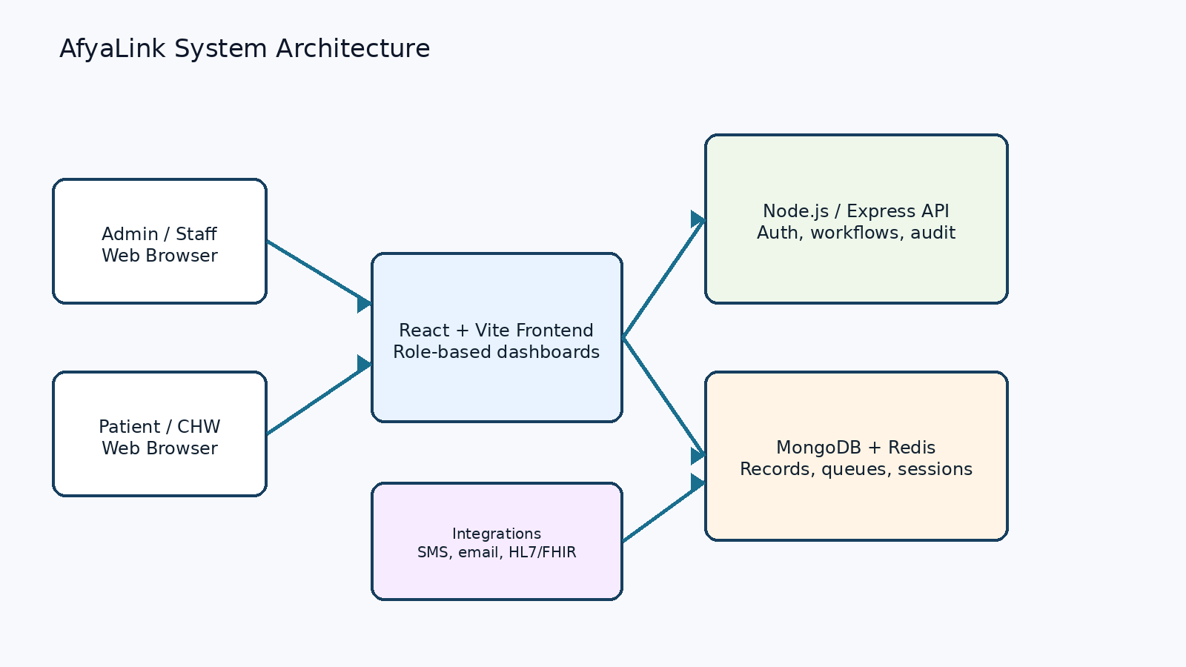
Fig 2.3-1 AfyaLink System Architecture

2.3.2 Data Flow Diagram
The data flow diagram shows how user requests move through AfyaLink from the user interface to processing and storage, then back as system responses.
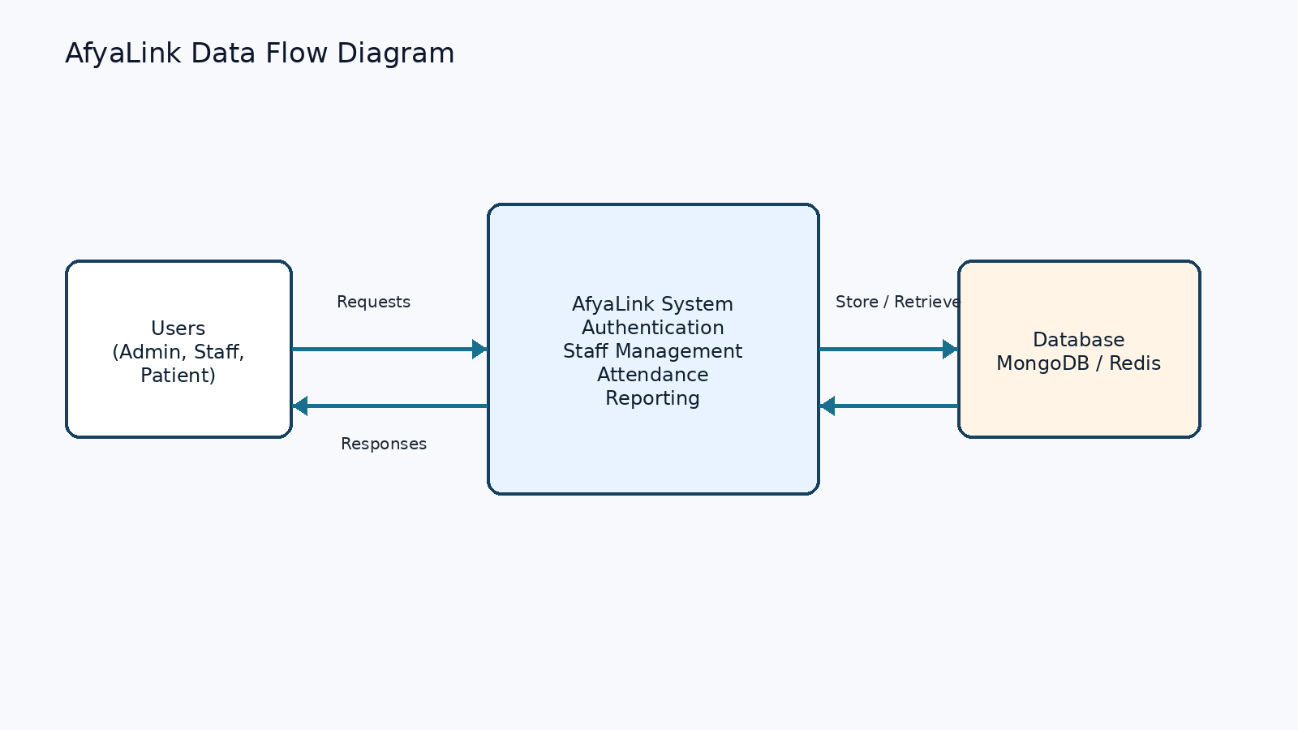
Fig 2.3-2 AfyaLink Data Flow Diagram

2.3.3 Use Case Diagram
The use case diagram shows how administrators and staff interact with login, staff management, attendance tracking, and report generation.
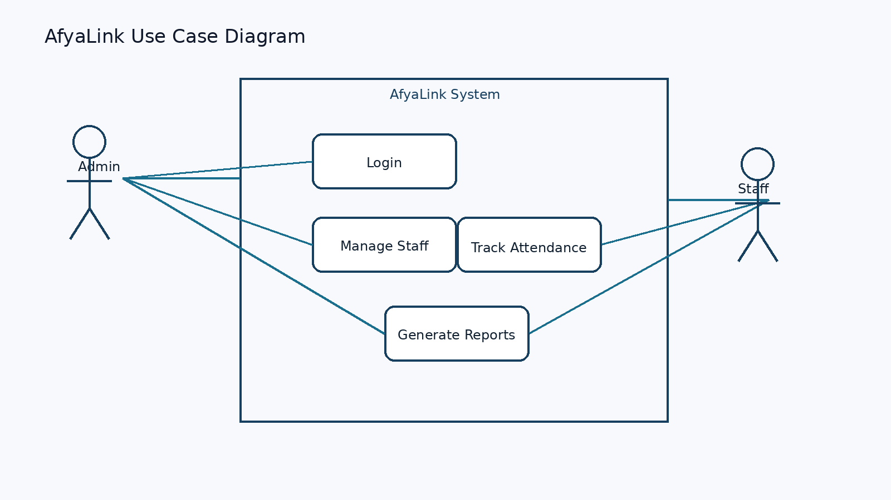
Fig 2.3-3 AfyaLink Use Case Diagram

CHAPTER THREE: SYSTEM IMPLEMENTATION
(DEVELOPMENT, TESTING AND DEPLOYMENT)

3.1 Introduction
This chapter explains the development journey of AfyaLink. It covers the frontend interfaces, backend logic, database models, testing activities, and deployment plan. The system was developed as a web application with a React frontend and a Node.js/Express backend, supported by MongoDB, Upstash Redis, and role-based security controls.

3.2 User Interface Development

3.2.1 Login Page Development
The login page was developed to allow users to access the system securely. It connects to authentication logic and protected routing so that users only access screens allowed by their roles.
Login Page Development Summary
Purpose: authenticate users before entering AfyaLink.
Main files: frontend/src/pages/Login, frontend/src/utils/auth.jsx, frontend/src/App.jsx.
Features: identifier input, password input, route redirection, protected routes, forgot password support, and two-factor flow support.

Fig 3.2-1 Login Page Development Summary

3.2.2 HR Manager Dashboard Development
The HR Manager dashboard was developed to give HR users quick access to staff records, attendance information, leave requests, and reports.
HR Dashboard Development Summary
Purpose: help HR managers monitor staff readiness and HR activities.
Main file: frontend/src/pages/HRManager/Dashboard.jsx.
Features: dashboard statistics, staff records, attendance table, reports summary, recruitment links, employee profiles, leave management, and navigation links.

Fig 3.2-2 HR Dashboard Development Summary

3.2.3 Staff Workspace Development
The staff workspace was developed to give non-administrative users a focused interface for requests, notifications, schedules, and role-specific workspaces. The interface changes according to user role, such as receptionist, HR staff, or general healthcare staff.

3.3 Logic Development

3.3.1 Authentication Logic
Authentication is handled in the backend using user records, password hashing, token generation, refresh sessions, OTP support, and audit logging. Secure authentication is important for protecting private information in healthcare systems (Government of Kenya, 2019; Sandhu et al., 1996).
register/login flow:
1. Receive user credentials from the frontend.
2. Sanitize email, phone, identifier, and password input.
3. Find the user record in MongoDB.
4. Compare the submitted password using bcrypt.
5. Generate access and refresh tokens using JWT.
6. Record important security actions in the audit log.
7. Return the authenticated user and route them to the correct dashboard.
Fig 3.3-1 Authentication Logic Code

3.3.2 Staff Management Logic
Staff management logic allows authorized users to create, view, update, and deactivate staff records. The backend checks hospital context and validates the staff role before saving or returning staff information.
staff management flow:
1. Resolve the hospital context from the logged-in user.
2. Validate the request body and selected staff role.
3. Check that the email does not already exist.
4. Evaluate the staff identity checklist.
5. Save the staff record in MongoDB.
6. Return safe staff details without password or refresh-token data.
Fig 3.3-2 Staff Management Logic Code

3.3.3 Reporting and Audit Logic
Reporting and audit logic supports accountability by recording important user actions and exposing reports to authorized users. This helps management review staff activities, access events, training records, requests, and operational indicators.

3.4 Testing
Testing was carried out to confirm that major features work as planned and that corrections can be made before submission. The project used unit testing, integration testing, route checks, and user acceptance review.
Table 3.4 Testing Summary
Test Area | Action Taken | Expected Result
Authentication | Tested login, protected routes, token handling, and role redirection. | Only valid users can access allowed dashboards.
Staff Management | Tested staff listing, creation, updating, and deactivation flows. | Staff records are stored and managed accurately.
Dashboard Pages | Checked HR manager and staff dashboard loading and navigation links. | Users can view the correct dashboard information for their roles.
Reports and Audit | Reviewed report routes and audit-related backend logic. | Authorized users can review system actions and reports.
Integration | Checked frontend API calls against backend routes and services. | Frontend and backend communicate using expected API endpoints.

3.5 Deployment
AfyaLink is prepared as a web-based system with the frontend deployed on Vercel, the backend deployed on Render, the main database hosted on MongoDB, and Redis services hosted on Upstash. The React frontend is built and deployed to Vercel so users can access the system through a browser. The Node.js and Express backend is deployed on Render to process authentication, staff management, attendance, reporting, and audit requests. MongoDB stores system records such as users, staff details, requests, and reports. Upstash Redis supports temporary data such as sessions and queue-related tasks. For local testing, the frontend can be started with npm run dev and the backend can be started with npm run start or npm run dev after configuring the required environment variables.

CHAPTER FOUR: CONCLUSION AND RECOMMENDATION

4.1 Conclusion
AfyaLink was developed to address the challenges healthcare institutions face when managing staff records, access control, attendance information, requests, reporting, and audit trails manually or through fragmented systems. Chapter One explained the problem, justification, objectives, functional requirements, tools, and project schedule. Chapter Two presented the user interface and logic models used to guide development. Chapter Three explained the implementation journey, including frontend development, backend logic, testing, and deployment planning. Through this project, I learned how to organize a full-stack healthcare system, connect frontend and backend features, apply role-based access control, and document a system according to academic project requirements.

4.2 Recommendation
Future developers who improve AfyaLink should consider adding simple attendance check-in options, improving report export formats, refining mobile responsiveness, and expanding the system to support more healthcare institutions. The system can also be improved by adding more testing and making the user interface easier for staff and administrators to use.

REFERENCES
Government of Kenya. (2019). Data Protection Act, 2019. Nairobi, Kenya: Government Printer.
Laudon, K. C., & Laudon, J. P. (2022). Management information systems: Managing the digital firm (17th ed.). Pearson.
Meta Open Source. (2026). React documentation. https://react.dev/
MongoDB. (2026). MongoDB documentation. https://www.mongodb.com/docs/
Node.js. (2026). Node.js documentation. https://nodejs.org/en/docs
Pressman, R. S., & Maxim, B. R. (2020). Software engineering: A practitioner's approach (9th ed.). McGraw-Hill.
Sandhu, R. S., Coyne, E. J., Feinstein, H. L., & Youman, C. E. (1996). Role-based access control models. Computer, 29(2), 38-47.
Sommerville, I. (2016). Software engineering (10th ed.). Pearson.
Vite. (2026). Vite guide. https://vite.dev/guide/

